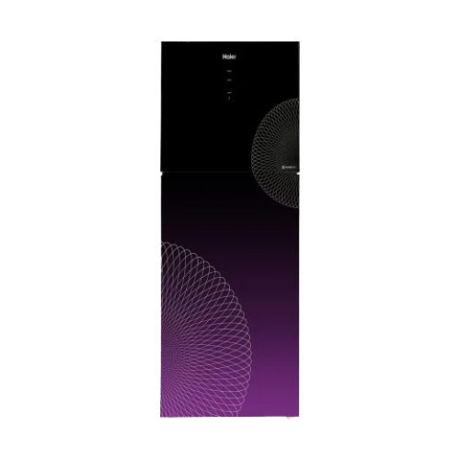**Liberty Electronics**

# Inverter Fridge Haier Digital Inverter Fresh Refrigerator 18 CF (438 Liter) HRF-438IFPA | Purple

**₨119,000**

Two time fresher

Digital Control SystemTop of Form

Bottom of Form